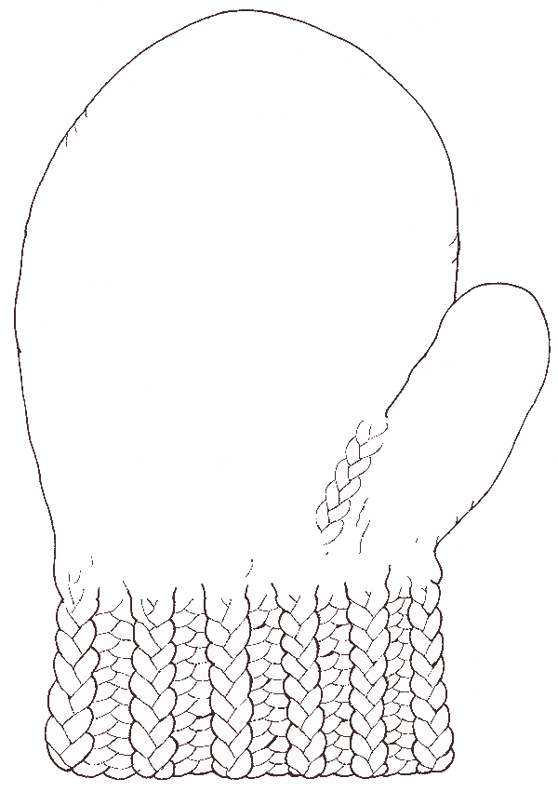
Materials from www.janbrett.com
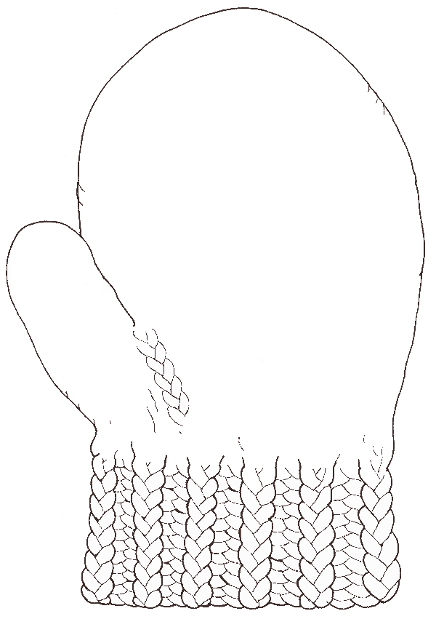
Materials from www.janbrett.com
Materials from www.janbrett.com
Retell the story, The Mitton by placing the animals in the mitten according to the book.
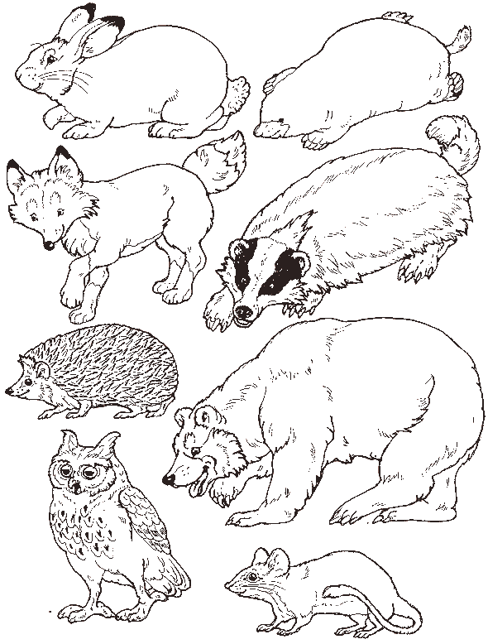
Materials from
http://www.dltk-teach.com/books/hungrycaterpillar/sequencing.htm
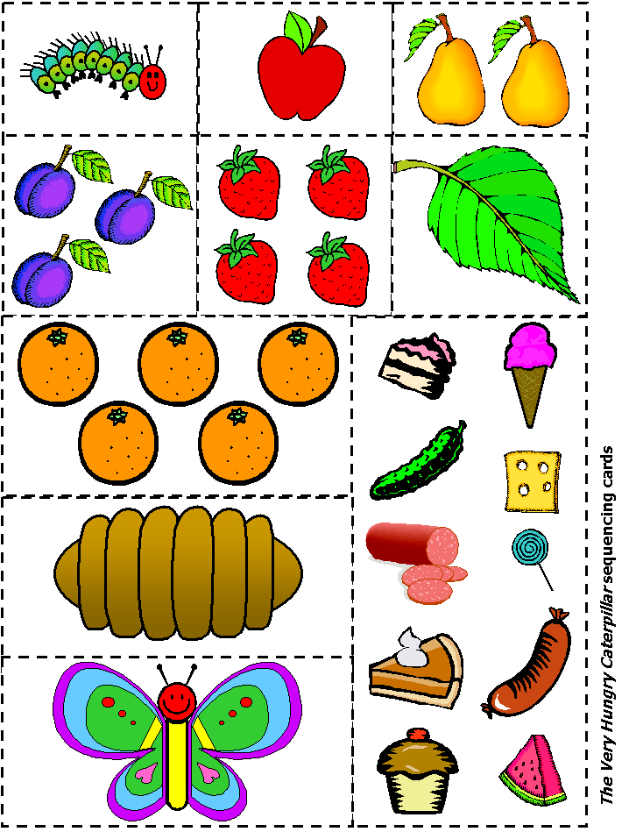

Directions for Making a Caterpillar/Butterfly Sock Puppet - Using a few supplies, you can make a puppet to show the stages of a butterfly. Start with a green or striped sock. Create the head of the caterpillar on the toe of the sock. Now, to show the cocoon stage, fold the top of the sock up and over the head (similar to how some people pair their socks for storage in a drawer). On the inside of the sock sew or hot glue two wings and another head.
To show the metamorphosis from cocoon to butterfly, simply turn the sock wrong side outwards. When you make the caterpillar enter the cocoon, make sure you don't show the wings. They should be further towards the head of the butterfly so that they only show when you turn the sock wrong side outwards.

Larger version of pictures – use for feeding caterpillar
Materials from
http://www.dltk-teach.com/books/hungrycaterpillar/sequencing.htm

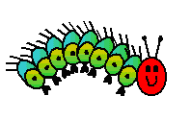

Materials from
http://www.dltk-teach.com/books/hungrycaterpillar/sequencing.htm



Materials from
http://www.dltk-teach.com/books/hungrycaterpillar/sequencing.htm

=
Materials from
http://www.dltk-teach.com/books/hungrycaterpillar/sequencing.htm
Materials from
http://www.dltk-teach.com/books/hungrycaterpillar/sequencing.htm

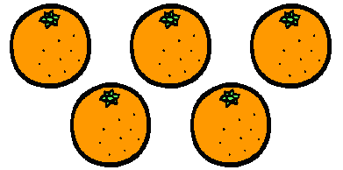
Materials from
http://www.dltk-teach.com/books/hungrycaterpillar/sequencing.htm


Materials from
http://www.dltk-teach.com/books/hungrycaterpillar/sequencing.htm

